**"PROJECT-TITLE: FARMING-MANAGEMENT SYSTEM"**

Submission-Date:18/12/2024

* **REPORT:**
* **INTRODUCTION:**

We are creating this database in order to manage data of farmer. It is a mini project with some tables. Here in this figure of ER-diagram, we just use 9 tables which includes for relationship you can see in this figure.

* **BUSINESS-RULE:**

1. **Farmers and Farms:**

* Each farmer can manage one or more farms.
* Each farm is managed by exactly one farmer.

1. **Farmer and Fields:**

* Each farmer having one or more fields.
* Each field belongs to exactly one farmer.

1. **Fields and Crops:**

* Each field is associated with one crop at a time.
* Each crop grows in one field.

1. **Fields and Fertilizers:**

* Each field uses multiple fertilizer.
* Each fertilizer analysis is associated with exactly one field.

1. **Fields and Irrigation Schedules:**

* Each field having one or more irrigation schedules.
* Each irrigation schedule is associated with exactly one field.

1. **Crops and Harvest Records:**

* Each crop having one or more harvest records.
* Each harvest record belongs to exactly one crop.

1. **Farmers and Financial Transactions:**

* Each financial transaction is linked to one and only one farmer.
* Each farmer can have multiple financial transactions.

1. **Farmers and Input Inventory:**

* One farmer manages one input inventory items.
* One inventory item belongs one and only one farmer.

1. **Farm and Fields:**

* One farm has many fields
* One fields belong to one and only one farm

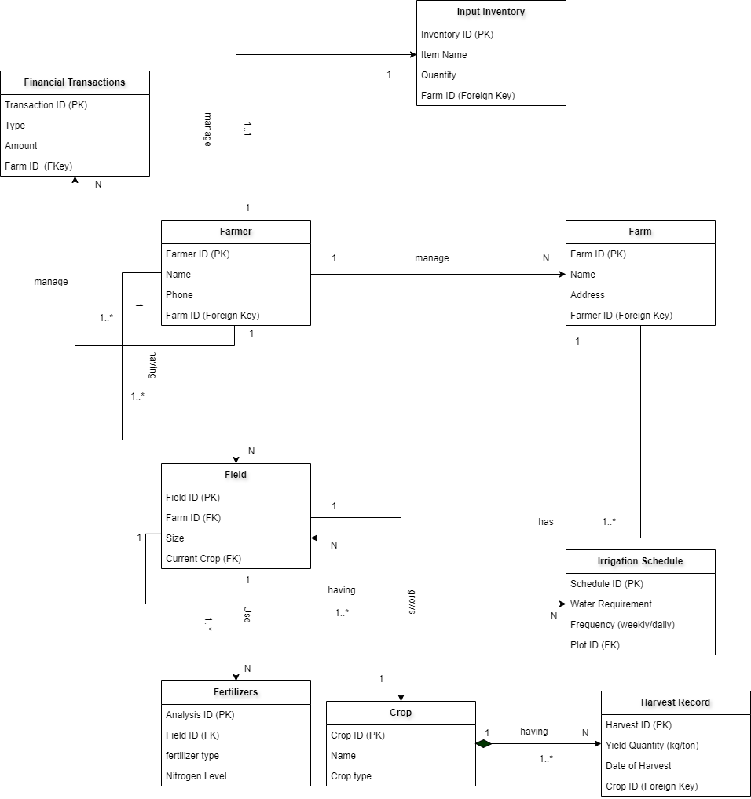

Fig: ER-Diagram

FF